- It is not passing the strucure field instead it is passing hardcode fields where to map the unmatched fields
PROGRAM: ZMM_MB1C
TCODE: MB1C
REPLACEMENT: BAPI_GOODSMVT_CREATE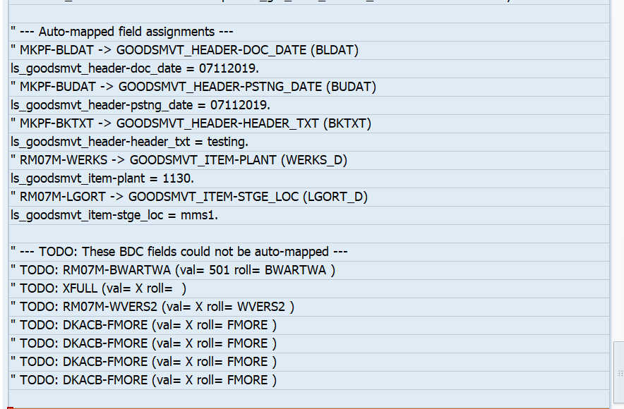

- Not fetching all the fields properly as it is passed in variable.
PROGRAM: ZFI_VEN_WT
TCODE: FK02
REPLACMENT: vmd_ei_api=>maintain
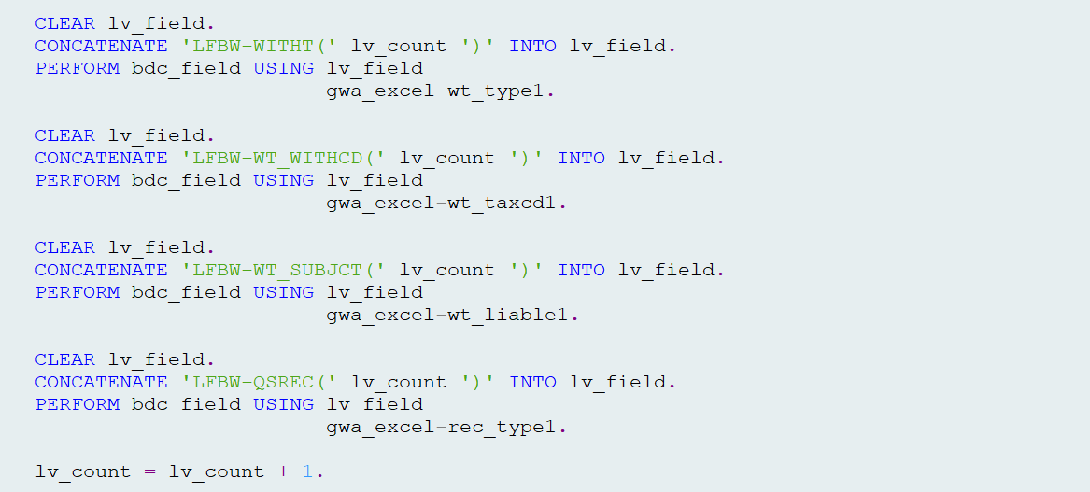
- Since FK01 is stored in variable and passed in CALL TRANSACTION so not able to find the tcode.
PROGRAM: ZFI_VEND_HONC
TCODE: FK02
REPLACEMENT: vmd_ei_api=>maintain
